Press Release
No: 117 PR/BHL/2019
Dhaka, August 1, 2019

Announcement of EID Cashback Offer

With ever-expanding customer acceptance of Honda motorcycles in Bangladesh, BHL plans to provide the joy to mobility with a special “Eid Cashback Offer” up to taka 12,000 for “CB Hornet 160R, Livo & Dream Neo”.
This offer starts on 1st August 2019 and will be valid till 17th August 2019.

The current motorcycle prices & “EID Cashback Offer” scheme is given below-
Model Name | Price in BDT | Cashback in BDT | Offer Price in BDT | Period | Additional Benefits
CB Hornet 160R Standard | 189,800 | 12,000 | 177,800 | 1st-17th August 2019 | Rain coat + Weekly Raffle Draw*
CB Hornet 160R Deluxe | 201,800 | 6,000 | 195,800 | 1st-17th August 2019 | Rain coat + Weekly Raffle Draw*
Livo Disc | 116,000 | 6,010 | 109,990 | 1st-17th August 2019
Livo Drum | 107,000 | 6,010 | 100,990 | 1st-17th August 2019
Dream Neo | 97,000 | 4,000 | 93,000 | 1st-17th August 2019

* Every new purchaser of CB Hornet 160R will be eligible to participate the weekly raffle draw and get a chance to win a CB Hornet 160R STD Athletic Blue Metallic.

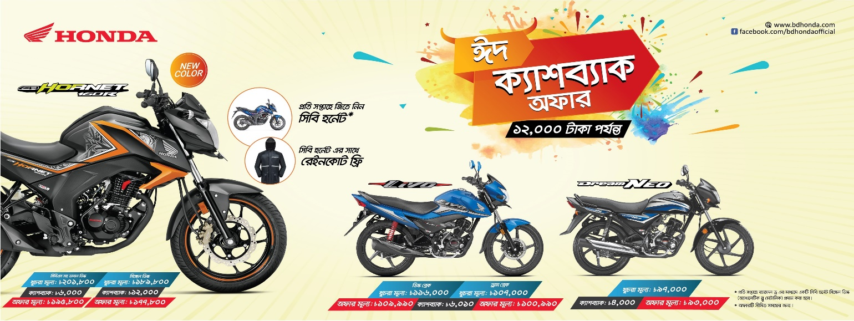

To avail this Eid Cashback Offer, new bike customers shall visit their nearest Honda Exclusive Authorized Dealer for detailed information & buy the new CB Hornet, Livo & Dream Neo models. Bangladesh Honda Private Limited reserves the rights to interpret, change or eliminate this offer any time.

Enjoy the ‘EID Cashback Offer’ with Honda’s affordable mobility.

Faithfully Yours

Himihiko Katsuki
Managing Director and CEO
Bangladesh Honda Private Limited (BHL)

